

Great Lakes Ringette League
Meeting Agenda
Monday September 21st, 2026 - 7:00 pm
ONLINE ONLY
ROLL CALL: (State your Association & Full Name)
Position/Association | Name | Present/Absent/Regrets
President | Shannon Crinklaw | Present
Vice President | Jim File | Regrets
Past President | Vacant | Vacant
Treasurer | Ron McArthur | Present
Secretary | Carrie McKichan | Present
RIC | Emma Bragg Smith | Present
Director at Large 1 | Colin Deans | Absent
Director at Large 2 | Adam Natsheh | Present
Director at Large 3 | Aaron Kratt | Present
Scheduler 1 | Steve Baker | Absent
Scheduler 2 | Tara Armstrong | Absent
Schedule 3 | Rob Ellis | Present
Ajax Pickering | Matt Tucker | Present
Barrie | Monique Dionne | Absent
Burlington | Kevin Aubertin | Regrets
Dorchester | Nicole Lindsay | Present
Durham 18+ | Chris George | Absent
Elora Fergus | Jolene West | Present
Forest | Rachel Orvis/ Ryan Lichty | Present
Guelph/University of Guelph | Jared Pulleybank | Present
Hamilton | Scott Eason | Absent
Kitchener | Jason Sewell | Absent
London | Jess Walker | Regrets
Mississauga | Andrea Law | Present
Mitchell | Carrie McKichan | Present
Oshawa | Jamie Lynn Vanderlinde | Present
Paris | Anne Hodgson | Present
Richmond Hill | Scott Dyer | Present
Stouffville 18+ | Fernanda | Present
Sudbury | Shelley Ahmad | Absent
Sunderland | April Carter | Present
Tillsonburg | Matt Freelan | Absent
Waterloo | Courtney Proudfoot | Present
University of Waterloo | Emily Sharpe | Absent
West Ferris | Cassie Helps/Jon Blahut | Present
Whitby | Stacey Beck | Present

Others in Attendance:

Requests for items to be added to the agenda & approval of agenda.

Approval- Dorchester

Second – Guelph

Approval of GLRL Meeting Minutes of August 25th, 2026

Link: Link to Meeting Minutes

Approval – Guelph

Second - Forest

Financial Report –Ron McArthur
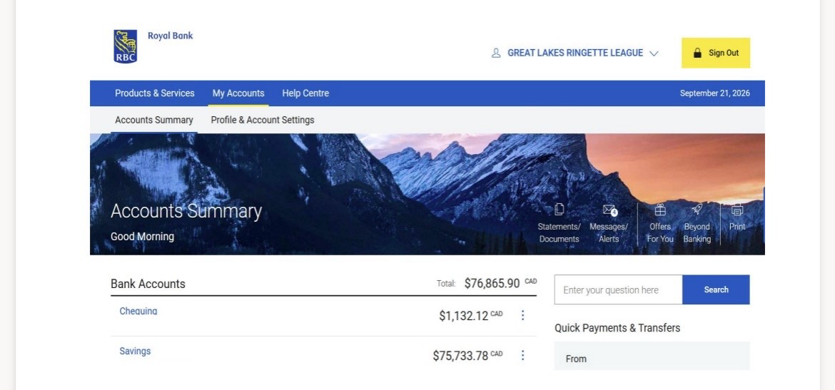
The league’s finances are solid with all team fees and association bonds fully paid and refunds already issued to teams that had overpaid, mainly due to the 18 plus teams playing half schedules paying full fees initially.
- The fee structure separates a $160 admin fee from referee mileage reimbursement, ensuring teams pay proportionally to their actual game count.
- Ron confirmed all expenses are on budget and the financial position is stable going into the season.
- Due to limited new financial milestones before November, the decision was made to skip the October meeting, with communication to be handled via email if urgent issues arise.
- This scheduling change aligns with the league’s normal cadence and avoids unnecessary meetings without new data to discuss.

Discipline Committee – Jim File

The discipline committee is fully established with an independent third party and referees; no cases have been submitted yet after the first weekend of play.

- Update to Rules – Update to GLRL Rules approved
The league finalized rule updates focused on clarity and operational responsibilities, with no content changes but improved presentation thanks to Aaron Kratt.
- A key update designates the hub weekend host as responsible for minor officials, instead of the home team for those weekends.
- Game lengths for the new 18 plus division are now codified: 4 periods of 11 minutes for 16 AA and U19AA games, with specific rules for 18+ matchups.
- Substitutions for 18 plus teams are now unlimited, but 19AA players cannot be used as substitutes.
- A new fine is introduced for deleting roster info after a game where a substitute player participated, to preserve game integrity.

- Scheduling Update – Jim File
The league faced significant scheduling issues, notably from setting the 18 plus teams’ schedules too early, causing last-minute changes and rework.
•The number of game change forms spiked past 60, exceeding 2023 totals due to early scheduling and late tournament announcements disrupting hubs like Sudbury.
•Requests to avoid playing on holidays like Halloween and Thanksgiving also contributed to changes.
•Concerns were raised about insufficient turnaround time between doubleheaders, with some associations opting to move games to other days.
•A major operational lesson is the strict enforcement that all schedule changes must use the official game change form, not email, to ensure referees and officials receive proper notifications.
•The hub weekend in London experienced issues including missing referee assignments caused by email changes not reflected in the official system.
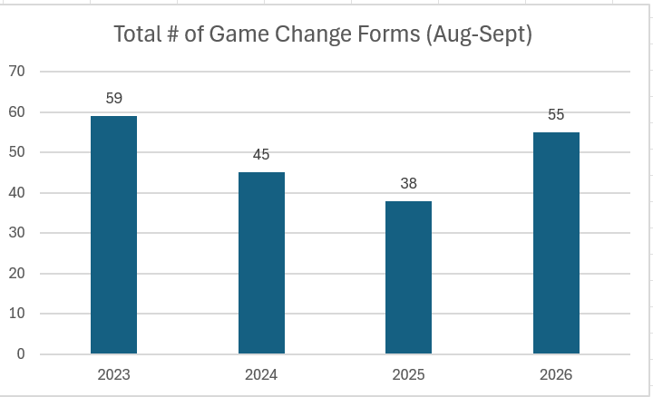

  - Hub Weekend Schedule

Dates | Locations | Divisions
Sept 19-20 | London | U16AA/U19AA
Sept 27 | Kitchener | U19AA
Oct 3-4 | Richmond Hill | U16AA/U19AA
Oct 24 | Burlington | U16AA
Nov 28 | Waterloo | U16AA
Dec 12-13 | Bala (Sudbury) | U16A/U19A

- RAMP Issues

Ramp’s removal of the player roster sync feature has significantly complicated roster management, forcing multiple manual entries and causing data inconsistencies across platforms.
- Teams can no longer sync player lists from association registrations automatically, leading to last-minute manual roster additions before games.
- Editing player names after game start is restricted, causing duplicate entries for the same player if corrections are needed.
- Stats are no longer visible on association websites due to lack of sync and must be viewed on the league’s site, creating confusion.
- The league has requested a meeting with Ramp and Ringette Ontario on Wednesday to address these disruptions and seek restoration of syncing or workable alternatives.
- Ramp’s new approval workflow requires league staff to manually approve every team roster submission, which is impractical and burdensome for volunteers.
- The league has engaged Ringette Ontario leadership, with Josh Hamilton supporting escalation to resolve these issues.
- Until solutions emerge, the league is preparing to revert to paper forms for game day processes if necessary to maintain operations.

- Officials Update – Emma
  - Officials Update getting ready for Next Season

League Convenors – Last Call for Volunteers

Description for Role:

Liaison for league game issues raised within the division assigned

Review scores of games have been entered

Contact to allow coaches to ask questions before coming to executive

Assist in game cancellation and reschedules if needed

Send emails to coaches to introduce yourself, Name posted on website

Required for:

U14A – Matt Freelen

U14AA – Monique Dionne

U16A - Vacant

U16AA - Vacant

U19A - Vacant

U19AA & 18+/University – Colin Deans

Other Business:
There are ongoing issues with the league website’s schedule display, notably that home and away teams are not clearly labeled and some non-league tournaments are erroneously shown.
- The home team appears on the right side of the schedule listing, which is counterintuitive and causes confusion.
- The league plans to request improvements from Ramp to clearly mark home vs. away teams and remove irrelevant tournaments from the main schedule page.
- This lack of clarity impacts teams, especially during hub weekends where both teams are “away” from their home arenas.
- League representatives encourage members to continue providing feedback on the website and Ramp functionality for the upcoming meeting.

Meeting Schedule for Year:
- September 21st
- October 19th (normally do not meet in October)
- November 23rd
- January 25th
- February 22nd
- AGM – TBD – May 2027

- Motion to adjourn.
Guelph
Second - Dorchester

